RIFT Authenticator explained
Table of Contents
1. Communication with TRION's servers 2
1.1. TRION server host names 2
1.2. SSL certificate verification 2
1.3. User-Agent 2
2. Secret key creation 3
2.1. Create a device id 3
2.2. HTTP POST request 3
2.2.1. URL 3
2.2.2. POST variables 3
2.2.3. Result 3
3. Time sync 4
3.1. HTTP GET request 4
3.1.1. URL 4
3.1.2. Result 4
4. Login token creation 5
4.1. Interval number 5
4.2. Creation of a valid login token 5
4.3. Additional information 5
5. Retrieve secret questions for a RIFT account 6
5.1. HTTP POST request 6
5.2. POST variables 6
5.3. Result 6
6. Recover the secret key for the authenticator 7
6.1. HTTP POST request 7
6.2. POST variables 7
6.3. Result 7
7. Device id for Android phones 8
8. Decrypting the secret key of the RIFT Authenticator for Android 9
8.1. Loading the configuration file 9
8.1.1. „Access denied“ problem 9
8.1.2. File format 9
8.2. Decryption of the secret key 9
8.3. SHA1 random number generator 9
9. Error codes 10
10. Legal information 11

Communication with TRION's servers
All communication uses the HTTPS protocol.

TRION server host names
We're communicating with the following TRION servers:
- The TRION Authentication server: https://auth.trionworlds.com
The request method is HTTP-GET.
- The TRION API server: https://rift.trionworlds.com
The request method is HTTP-POST.

SSL certificate verification
The SSL certificates for the server must always have a CN (common name) that ends with one of the following host names:
- .trionworlds.com
- .triongames.com
- .trionworld.priv
- .triongames.priv

User-Agent
The user agent used by the RIFT Authenticator for Android is somehting like this:
RIFT Mobile Authenticator {0}; Android {1} ({2}); {3}, {4}, {5};
Placeholder | Description | Example
{0} | Authenticator application version. | 1.0.4
{1} | Android version. | 2.3.3
{2} | Android SDK version. | 10
{3} | Android product. | GINGERBREAD*
{4} | Cell phone model. | HTC Desire*
{5} | Cell phone brand. | O2*
* I'm not sure if this is correct.

Secret key creation

Create a device id
The device id can be any combination of the characters A-Z and digits 0-9. I don't know what the maximum length is, but you can at least use 32 characters and digits.
Hint: You should create a device id that can always be calculated for a mobile device (simple) or a computer (not so simple).
When it's not possible to choose/create such a device id, then you should notify the user about the importance of the device id.

HTTP POST request

URL
https://rift.trionworlds.com/external/create-device-key

POST variables
Name | Description
deviceId | The device id TRION has to generate the secret key for.

Result
The request returns a XML file with one or more of the following fields (in XPath notion):
XPath | Description
/DeviceKey/DeviceId | The same device id as created by the client.
/DeviceKey/SerialKey | The authenticator serial number requested by Trion when you enable using the Authenticator in your Rift profile.
/DeviceKey/SecretKey | This is the secret key itself. It’s not encrypted.
/DeviceKey/ErrorCode | This is an error id. This field is missing when everything is OK.

Time sync

HTTP GET request

URL
https://auth.trionworlds.com/time

Result
This returns the time (just the number, no fancy XML stuff). The time offset is calculated as (server_time – client_time). Both numbers are milliseconds starting from 01. Jan. 1970.

Login token creation
For the login token creation, we need both the secret key (see Secret key creation) and the time offset (see Time sync).
Every login token is valid for 30 seconds. This time span is denoted by an interval number. This interval number will be used to calculate the login token.

Interval number
It's calculated using the following formula:
(current_time_millis + time_offset) / 30000
This also implies, that every interval starts at HH:MM:00 or HH:MM:30 with HH=Hours, MM=Minutes.

Creation of a valid login token

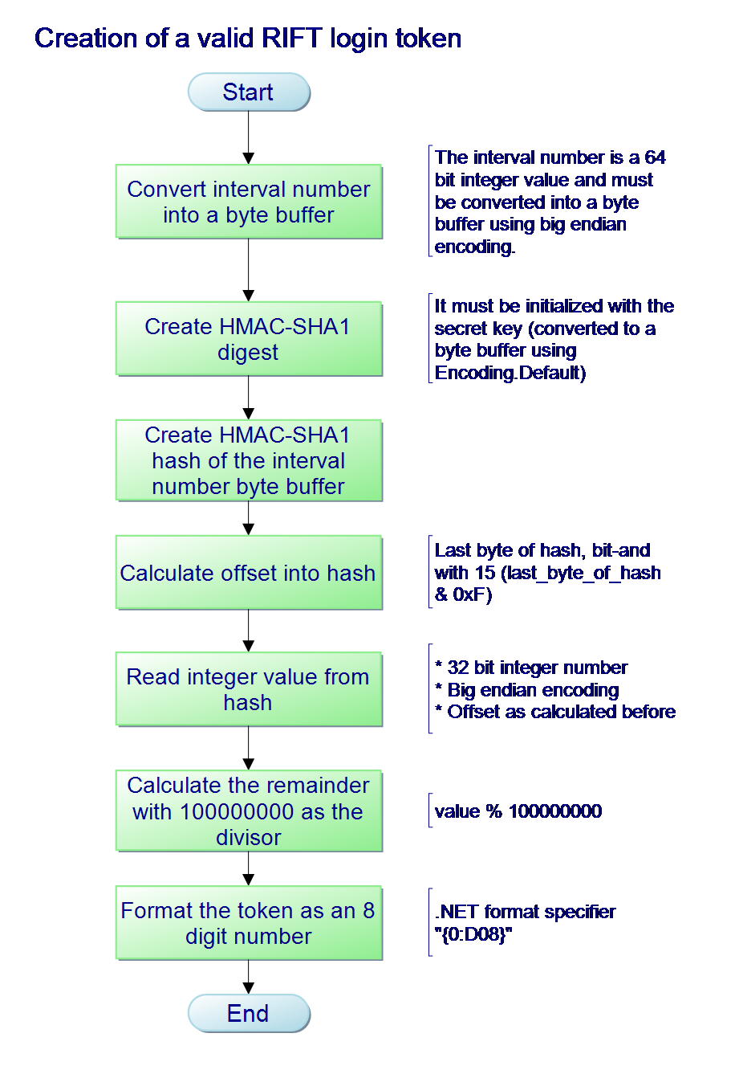
Additional information
A useful tool for the big endian conversion to and from byte buffers is Mono.DataConvert.

Retrieve secret questions for a RIFT account
Retrieving the secret questions for a RIFT account is required to recover the secret key (Recover the secret key for the authenticator) using a device id.

HTTP POST request
https://rift.trionworlds.com/external/get-account-security-questions.action

POST variables
Name | Description
emailAddress | The Email address you use as login user name for Rift.
password | The password for the Rift login.

Result
The response is a XML file with the following XML elements (given in XPath notion):
XPath | Description
/SecurityQuestions/EmailAddress | The same Email address as given in the URL.
/SecurityQuestions/FirstQuestion | The first security question.
/SecurityQuestions/SecondQuestion | The second security question.
/SecurityQuestions/ErrorCode | An error ID if something failed.

Recover the secret key for the authenticator
When you know your device id and your login + answers to the secret questions, then you can recover the secret key. This feature was added to the RIFT Authenticator for Android Version 1.0.3.

HTTP POST request
https://rift.trionworlds.com/external/retrieve-device-key.action

POST variables
Name | Description
emailAddress | The Email address you use as login user name for Rift.
password | The password for the Rift login.
deviceId | The device id that you used to create the secret key.
securityAnswer | The first security answer (leave empty if none required).
secondSecurityAnswer | The second security answer(leave empty if none required).

Result
The result is a XML file in the same format as documented in the chapter „Secret key creation“.

Device id for Android phones
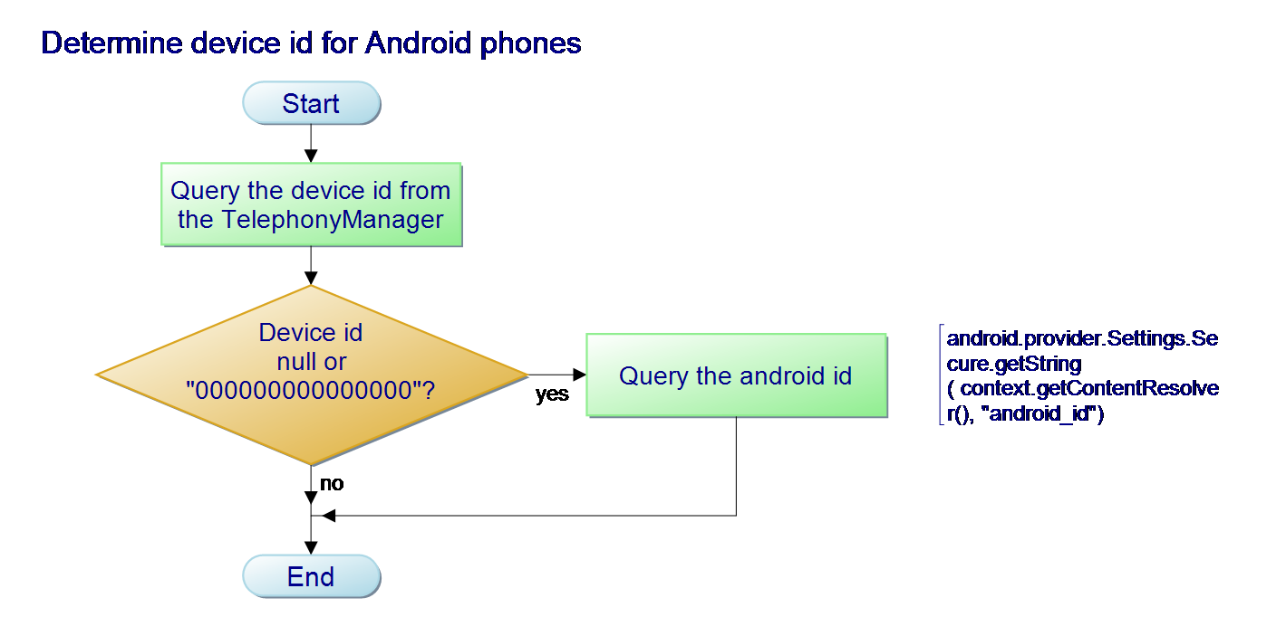

Decrypting the secret key of the RIFT Authenticator for Android

Loading the configuration file
On my phone, the configuration file is stored in the following location:
/data/data/com.trionworlds.mobile.auth/shared_prefs/system.xml

„Access denied“ problem
The access to the shared preferences of a different application isn't possible by default. You have to use „su“ on a rooted android phone to access this file.

File format
The preferences file is a XML file with the following contents (in XPath notion):
XPath | Value element | Description
/map/string[@name='device_id'] | text() | The Device id for Android phones.
/map/string[@name='secret_key'] | text() | The encrypted secret key.
/map/string[@name='serial_key'] | text() | The serial key used for registering an authenticator for a RIFT account.
/map/long[@name='time_offset'] | @value | The time offset between client and server.  Milliseconds since 1970-01-01.

Decryption of the secret key
- Create a SHA1 random number generator.
- Initialize it with the „TrionMasterKey_031611“ as seed (after converting it into a byte array).
- Create the key for the AES 128 cipher (16 bytes).
- HEX-decode the encrypted secret key.
- Decrypt the HEX-decoded encrypted secret key.

SHA1 random number generator
Android uses a bug-fixed SHA1 random number generator from the Apache Harmony project. I converted it to C# to have exactly the same behaviour as on my Android phone.

Error codes
Code | Description
device_id_missing | Device id variable missing in request.
account_not_available | Invalid user name or password.
account_missing | No RIFT account or device id doesn't match.
account_securityAnswers_incorrect | Security answer(s) incorrect.
account_securityAnswer_missing | No security answer(s) given.

Legal information
This documentation is under the copyright of the RIFT Authenticator for Windows project. RIFT is a trademark of TRION Worlds Inc, Redwood City, CA.

RIFT Authenticator explained by RIFT Authenticator for Windows project is licensed under a Creative Commons Attribution-NonCommercial-ShareAlike 3.0 Unported License.

